Decorator Design Pattern in Java

Introduction
The Decorator design pattern attaches additional responsibilities to an object dynamically. It is wrapping up at another object. It will extend functionality of object without affecting any other object. Decorators provide an alternative to subclassing for extending functionality.

When to Use It
Use Decorator
To add responsibilities to individual objects dynamically without affecting other objects.

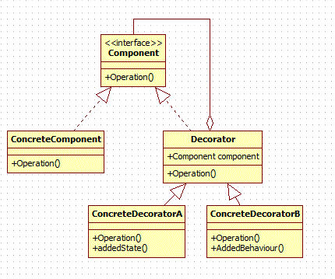

Elements
- Component
  - defines interface for objects that can have additional responsibilities added to them.
- ConcreteComponent
  - defines an object on which additional responsibilities can be added
- Decorator
  - Maintains a reference to component object and defines an interface that conforms to component's interface. In simple words, it has a component object to be decorated.
- ConcreteDecorator
  - add responsibilities to the component object.

Example
In this example, we will decorate a simple room with color and curtains.

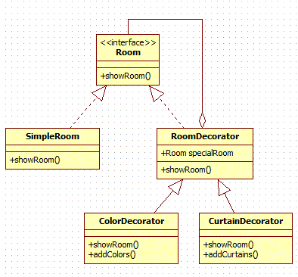
- Room(Component)
  - It is an interface which creates a blue print for the class which will have decorators
- SimpleRoom(ConcreteComponent)
  - Object of SimpleRoom class will be decorated. Additional responsibilities will be attached to it dynamically.
- RoomDecorator(Decorator)
  - It contains reference to Room class which will be decorated.
- ColorDecorator(ConcreteDecorator)
  - ColorDecorator will add additional responsibility i.e., add color to room.
- CurtainDecorator(ConcreteDecorator)
  - CurtainDecorator will add additional responsibility i.e., add curtains to room.

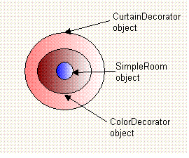
Logically, you can think of decorator pattern as shown in the above diagram. You will first create SimpleRoom object then decorate it with ColorDecorator object and then decorate resultant object with CuratainDecorator.

Java code for above classes:
The following interface is an interface depicting an room.
Room.java(Component):
public interface Room{
public String showRoom();
}
The following class is a concrete implementation of this interface. This is the base class on which the decorators will be added.
SimpleRoom.java(ConcreteComponent):

public class SimpleRoom implements Room {

@Override
public String showRoom() {
return "Normal Room";
}

}
The following class is the decorator class. It is the core of the decorator design pattern. It contains an attribute for the type of interface. Instance is assigned dynamically at the creation of decorator using its constructor. Once assigned, that instance method will be invoked.
RoomDecorator.java(Decorator):
abstract class RoomDecorator implements Room{

protected Room specialRoom;

public RoomDecorator (Room specialRoom) {
this.specialRoom= specialRoom;
}

public String showRoom() {
return specialRoom.showRoom();
}
}
The following class is our concrete decorator class. It extends abstract decorator. When this decorator is created, the base instance is passed to constructor which calls super class constructor. In showRoom() method, we call base class method followed by its own method addColors(). This addColors() adds functionality to base instance, i.e., decorating room with colors.
ColorDecorator.java(ConcreteDecorator):

public class ColorDecorator extends RoomDecorator {

public ColorDecorator (Room specialRoom) {
super(specialRoom);
}

public String showRoom() {
return specialRoom.showRoom() + addColors();
}

private String addColors() {
return " + Blue Color";
}
}
The following class is also concreteDecorator class similar to the above class. Here addCurtains() adds functionality to room(base instance), i.e., decorating room with curtains.
CurtainDecorator.java(ConcreteDecorator):
public class CurtainDecorator extends RoomDecorator {

public CurtainDecorator (Room specialRoom) {
super(specialRoom);
}

public String showRoom() {
return specialRoom.showRoom() + addCurtains();
}

private String addCurtains() {
return " + Red Curtains";
}
}
DecoratorDesignPatternMain.java:

public class DecoratorDesignPatternMain {

public static void main(String args[]) {
Room room = new CurtainDecorator(new ColorDecorator(new SimpleRoom()));
System.out.println(room.showRoom());
}
}
We have created a simple Room and decorated that with color and curtains.
Output:
Normal room + Blue Color + Red Curtains

Advantages of Decorator Design Pattern
- It is flexible than inheritance because inheritance adds responsibility at compile time but decorator pattern adds at run time.
- We can have any number of decorators and also in any order.
- It extends functionality of object without affecting any other object.

Decorator Design Pattern in Java API

java.io.BufferedReader;
java.io.BufferedWriter;
java.io.FileReader;
java.io.Reader;
The above classes of Java API are designed using decorator design pattern.

